**UNIT 3**

1. **Describe the differences and similarities between problem solving and planning. Use suitable example to support your answer.**

Sol: Planning is the act of deciding a set of actions to be performed, in agent environment based on the perception to achieve the desired goal. In a way, planning is problem solving before executing. Planning = Problem Solving + Logical Representation. The two terms have been compared below

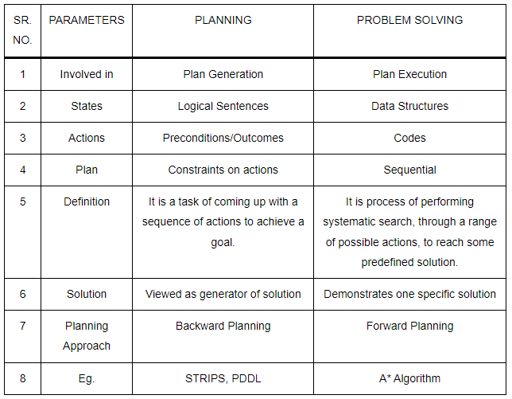

1. **Write the PDDL description for the blocks world problem. (Initial states and goal states are provided in the below figure.)**

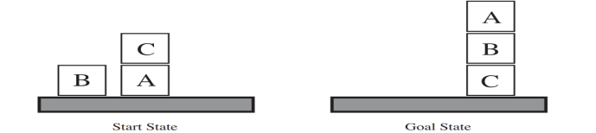

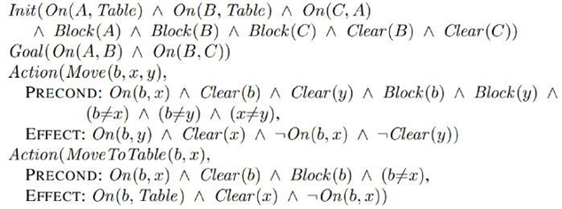

Then one solution is:

1. MoveToTable(C,A)

2. Move(B, Table, C)

3. Move(A, Table, B)

1. **Write the PDDL description of an air cargo transportation planning problem. Let SFO and JFK are the airports, C1 and C2 are cargos and P1 and P2 are planes. Initially C1 and P1 are at SFO, C2 and P2 are at JFK. In the goal state C1 should be at JFK and C2 at SFO.**

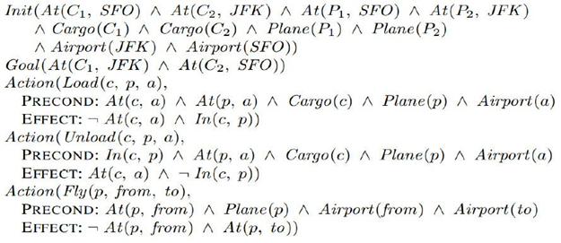

**solution:**

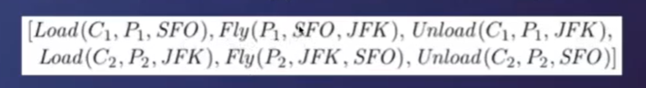

1. **Write the PDDL description for the Spare tire problems**

**Consider the problem of changing a flat tire**

**Initial state:**Flat tire on the axle and Good spare tire in the trunk.

**Goal:Good spare tire properly mounted onto the car’s axle**

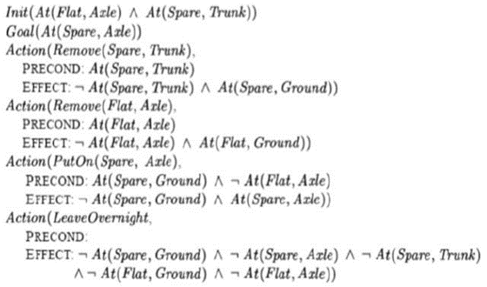

1. **Write the GRAPHPLAN Algorithm and explain how it works. Formulate the Planning graph for the spare tire problem.**

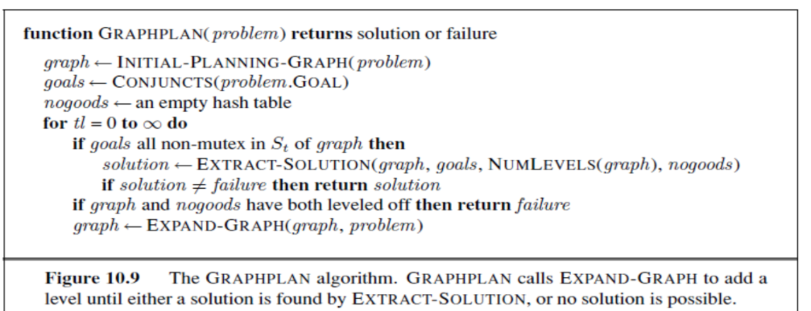

**The planning graph for spare tire problem is given below:**

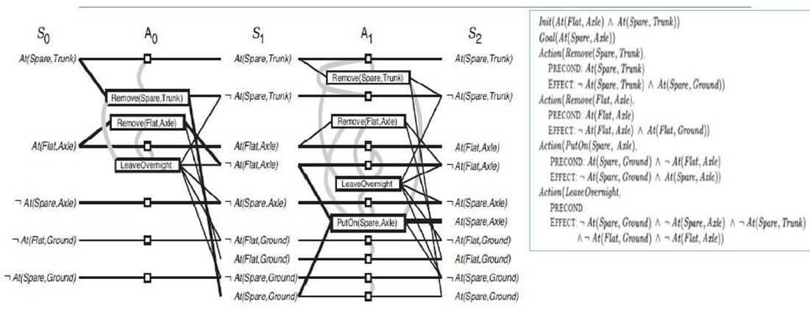

1. Illustrate Problem decomposition into AND-OR graph with example. (**New Question)**

**Sol : Q8 Unit 2 Maybe**

1. **Discuss how you draw inference using full joint distribution focusing on the rules of conditioning and marginalization.**

**Given the full joint distribution for the toothache, cavity and catch world:**

|  | **Toothache** | | **¬toothache** | |
| --- | --- | --- | --- | --- |
|  | **Catch** | **¬catch** | **Catch** | **¬catch** |
| **cavity** | **0.108** | **0.012** | **0.072** | **0.008** |
| **¬cavity** | **0.016** | **0.064** | **0.144** | **0.576** |

Calculate the following:

* P(¬toothache V cavity) = 0.072+0.008+0.144+0.576+0.108+0.012
* P(¬cavity) = 0.016 + 0.064 + 0.144 + 0.576
* P(toothache | cavity V ¬catch)

= P(toothache ^ p(cavity V ¬catch)) / P(cavity V ¬catch)

= (0.108+0.012+0.064)/(0.108+0.012+0.064)

* P (cavity | toothache V catch)

= P (cavity ^( toothache V catch)) / P (toothache V catch)

= (0.108+0.012+0.072)/(0.018+0.012+0.072+0.016+0.064+0.144)

Sol:

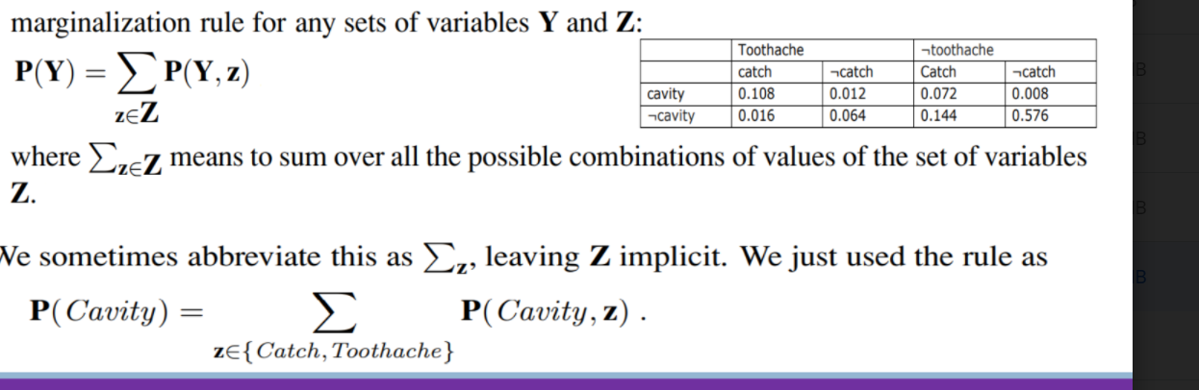

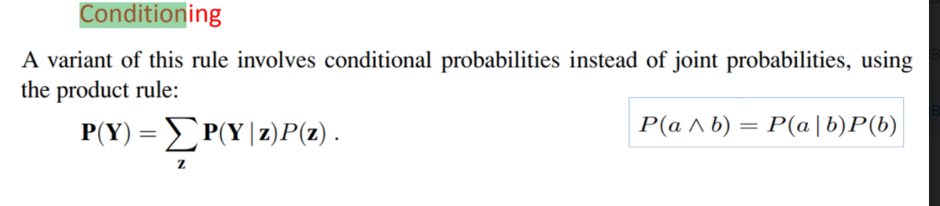

1. **Define Bayes rule. Give examples.**

**Bayes rule:** it is a mathematical formula used to determine the conditional probability of events **Bayes' Rule states that: P(A|B) = (P(B|A)*P(A)) / P(B)**

Example:

Let A = Patient has liver disease; P(A) = 0.1 assume

Let B = Patient is an alcoholic, P(B) = 0.05 assume

Among the patients having liver disease, 7% are alcoholics. Then P(B|A) = 0.07

Then to find the probability of a person having liver disease given he's an alcoholic, we use Bayes' Rule:

P(A|B) = P(B|A)*P(A) / P(B) = (0.07*0.1)/0.05 = 0.14

**SEE Questions:**

**1)Give comparison between stripes and adl langage for representation of planning problem**

[answer](https://neelshelar.com/strips-vs-adl-planning-languages-in-ai/)

**2)Differentiate between supervised and unsupervised learning methods using suitable examples.**

**Supervised Learning:** The machine has a “teacher” who guides it by providing sample inputs along with the desired output. The machine then maps the inputs and the outputs. This is similar to how we teach very young children with picture books. According to Yann LeCun, all of the AI machines we have today have used this form of learning (from speech recognition to self-driving cars).

Types of **supervised Learning: Classification**: Supervised learning problem that involves predicting a class label. **Regression**: Supervised learning problem that involves predicting a numerical label. examples of **supervised learning** include classifying e-mails into spam and not-spam categories, labeling webpages based on their content, and voice recognition.

**Unsupervised Learning**: This is the most important and most difficult type of learning and would be better titled Predictive Learning. In this case the machine is not given any labels for its inputs and needs to “figure out” the structure on its own. This is similar to how babies learn early in life. For example they learn that if an object in space is not supported it will fall

Types of **Unsupervised Learning:**

**Clustering: Unsupervised** learning problem that involves finding groups in data.

**Density Estimation**: Unsupervised learning problem that involves summarizing the distribution of data.

Examples for **Unsupervised learning**: 1. Finding customer segments. 2.Reducing the complexity of a problem

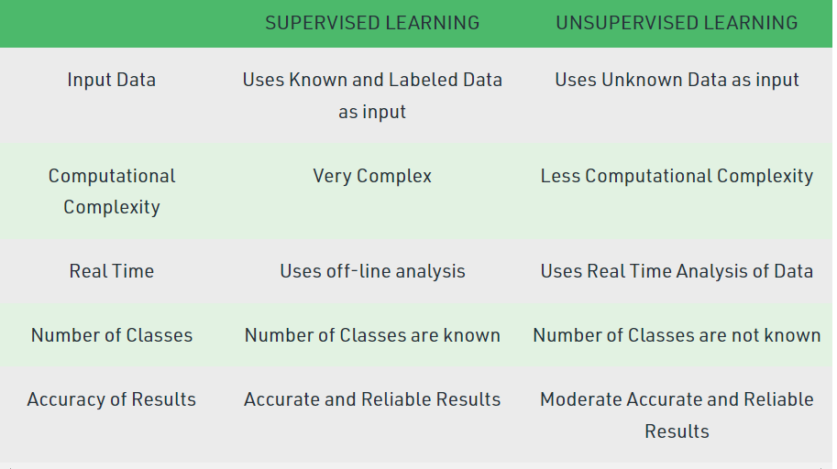

**3)Explain Decision tree algorithm with an example.**

Decision Tree algorithm belongs to the family of supervised learning algorithms and it is used for solving regression and classification problems.

**4) The task of finding and removing apples that house worms before they get to the grocery store is a big problem. Consumers have been shown to react poorly upon finding worms in their apples. To combat this problem. Wormfinder Inc. has developed an amazing new non-intrusive test for worms in apples. This test is, called WormScan hasthe incredible false negative rate of exactly 0 (i.e., if an apple is declared by WormScan to be free of worms, it is guaranteed to have no worms in it). Unfortunately, such a performance comes with a cost; the false positive rate is 3% (i.e., 3% of all good apples are marked as having a worm inside). Statistically, it has been found that 0.2% (1 in 500 apples) have worms.**

**(i) What percentage of the apples will test as having worms?**

**(ii) Given that an apple has tested as having worms, what is the probability that there is a worm inside?**

[answer](https://www.cse.unr.edu/~bebis/CS479/Ass/Ass1Sol.pdf)

**5) Stating the case study of toothache problem, explain how inference can be done using full joint distribution.**

6)

7)

8)

9)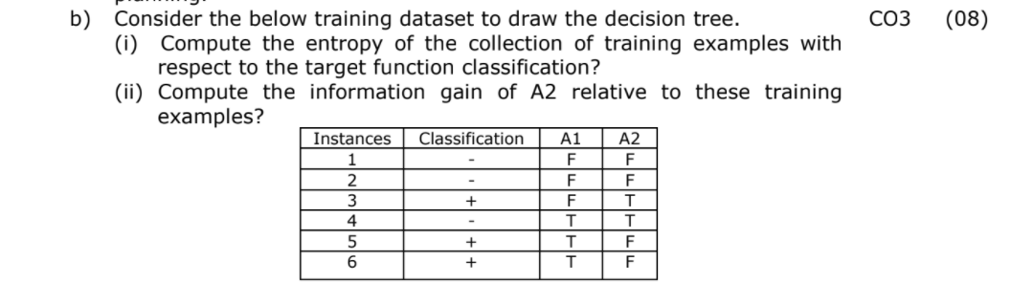

10)Discuss about support vectors in SVM? Explain using diagrammatical representation.

[**answer**](https://www.javatpoint.com/machine-learning-support-vector-machine-algorithm)

11)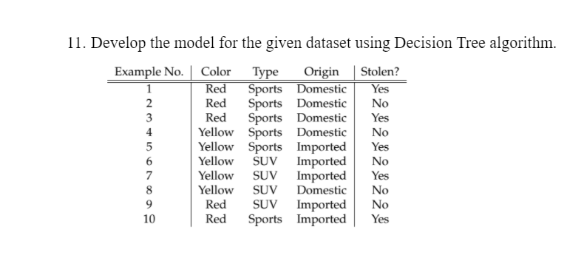

12)explain different types of learning (page 118 in ppt)

* Supervised learning
* Unsupervised learning
* Reinforcement learning

Q) Explain decision tree

• Decision Tree is a Supervised learning technique that can be used for both classification and Regression problems, but mostly it is preferred for solving Classification problems.

• A decision tree represents a function that takes as input a vector of attribute values and returns a “decision”—a single output value.

• The input and output values can be discrete or continuous.

• In a Decision tree, there are two nodes, which are the Decision Node and Leaf Node. Decision nodes are used to make any decision and have multiple branches Leaf nodes are the output of those decisions and do not contain any further branches. The decisions or the test are performed on the basis of features of the given dataset.

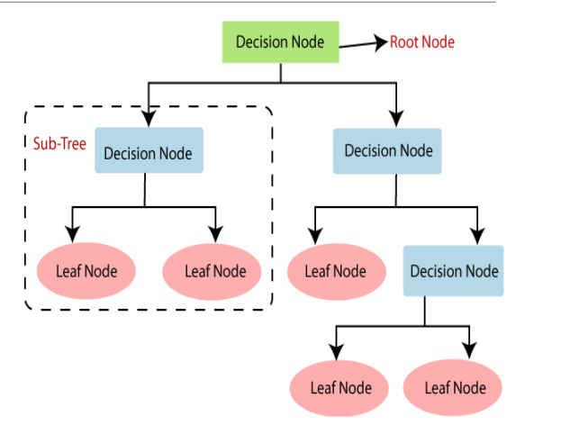

A decision tree reaches its decision by performing a sequence of tests. Each internal node in the tree corresponds to a test of the value of one of the input attributes, Ai, and the branches from the node are labeled with the possible values of the attribute, Ai =vik. Each leaf node in the tree specifies a value to be returned by the function.